For Immediate Release

  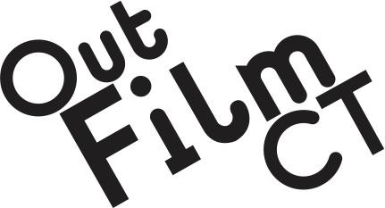
  Media Contact
  Shane Engstrom
  Phone: (860) 922-7480
  Email: director@outfilmct.org
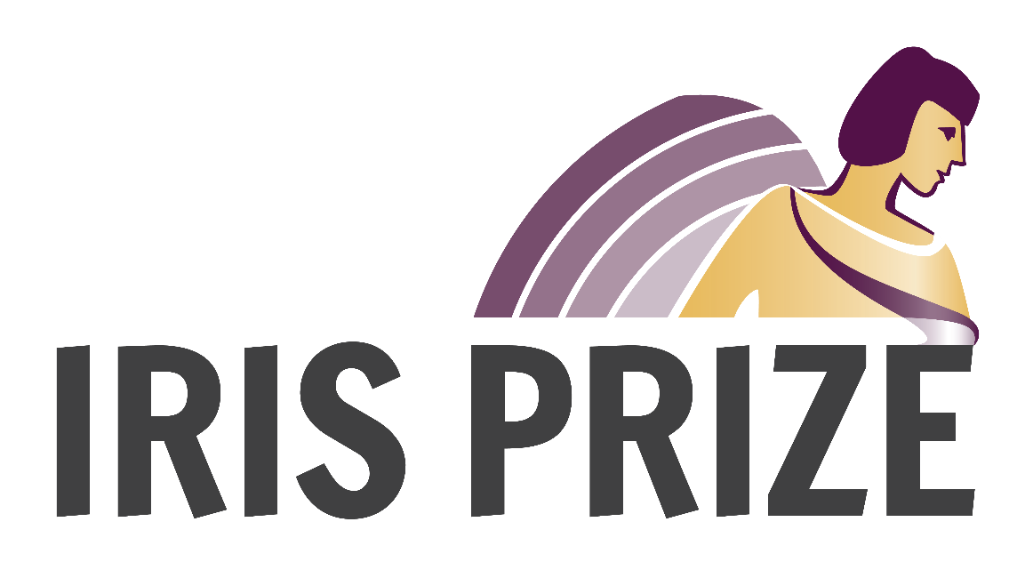

Out Film CT Announces Partnership with Prestigious Iris Prize LGBTQ+ Film Festival
February 9, 2026/Hartford, CT... Out Film CT, organizer of Connecticut's longest-running and most diverse film festival, announced today a partnership with the prestigious Iris Prize LGBTQ+ Film Festival, based in Cardiff, UK, which awards the largest prize for a LGBTQ short film in the world, worth $55,000 in cash. The Connecticut LGBTQ Film Festival will become a “nominating festival” for the Iris Prize, which allows Connecticut to make its imprint on this important worldwide contest. By nominating a short film for the Iris Prize, Out Film CT’s selection will bypass all of the intermediary steps, sending it to the final round of the selection process.
Berwyn Rowlands, Iris Prize Festival Founder and Director said: "We've relied on partner festivals to be our eyes and ears, to select what they consider to be an example of excellence in storytelling. Each year a small group of film festivals select one film each to go through to the Iris Prize final and a chance to win £40,000 ($55,000) to make a new short film. In this our 20th anniversary year we are thrilled to invite Out Film CT’s Connecticut LGBTQ Film Festival to join the family of nominating festivals, which also includes Frameline who are celebrating their 50th anniversary this year."
Shane Engstrom, Out Film CT President and Festival Director added: "Out Film CT is honored to partner with the prestigious Iris Prize to showcase and support imaginative storytelling by emerging LGBTQ+ filmmakers. We are excited to participate in this global event that brings the community together to celebrate the talent, creativity and unique vision of LGBTQ+ artists."
Becoming a nominating festival recognizes the Connecticut LGBTQ Film Festival’s prominence as one of the longest-running and most highly respected queer film festivals in the United States.
The 39th annual Connecticut LGBTQ Film Festival will take place in June 2026.

About Out Film CT
Out Film CT’s mission is to entertain, educate and promote community through the exhibition of LGBTQ film. As a volunteer, nonprofit cultural organization, Out Film CT is dedicated to presenting outstanding LGBTQ cinema and other theatrical events throughout the year, culminating in the annual Connecticut LGBTQ Film Festival. Connecticut’s longest-running film festival holds a special place in our state’s cultural landscape, bringing the community together to introduce, celebrate and rediscover the ideas and values that make the LGBTQ community unique. Out Film CT also presents the monthly Queer Thursdays film series in partnership with Cinestudio, usually shown on the second Thursday of each month.
###

Out Film CT | director@outfilmct.org | OutFilmCT.org

Connect with us


